
Proverbs 16:3 & Romans 10:9
RED LION YOUTH FOOTBALL
Age 10-11 Division 2026 – 12 Teams (Games will be played at 330pm and 5pm)
Teams should arrive 1 hour prior to their game for practice
*Everyone must play at least 50% of the Game *
“THINK POSITIVE BE POSITIVE “
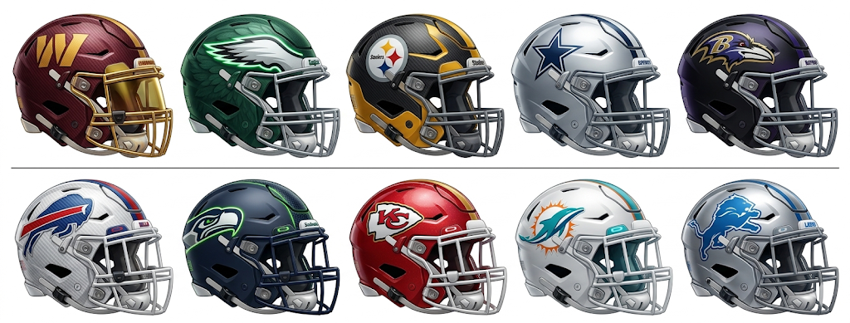
Date Time Home Team Away Team Field
Week 1 - * ARRIVE 1 hour prior to your game for practice * THINK POSITIVE BE POSITIVE!
- Sun 3/29/2026 330pm Packers Ravens #1 -Stadium
- Sun 3/29/2026 330pm Eagles Bills #2- Stadium
- Sun 3/29/2026 330pm Seahawks Bucs #3- Turf
- Sun 3/29/2026 330pm Chiefs Commanders #5- Turf
- Sun 3/29/2026 330pm Lions Cowboys #6- Grass
- Sun 3/29/2026 500pm Dolphins Steelers #6- Grass

4/5/26 WE are off on Easter Sunday * Happy Easter and Resurrection DAY!
We wish you and your families a very Happy Easter and a meaningful Resurrection Day. We look forward to seeing everyone back and energized next week!


Proverbs 16:3 & Romans 10:9
RED LION YOUTH FOOTBALL
Age 10-11 Division 2026 – 12 Teams (Games will be played at 330pm and 5pm)
Teams should arrive 1 hour prior to their game for practice
*Everyone must play at least 50% of the Game *
“THINK POSITIVE BE POSITIVE “

Week 2 * ARRIVE 1 hour prior to your game for practice * THINK POSITIVE BE POSITIVE!
- Sun 4/12/2026 330pm Eagles Steelers #1 -Stadium
- Sun 4/12/2026 330pm Cowboys Dolphins #2- Stadium
- Sun 4/12/2026 330pm Ravens Lions #3- Turf
- Sun 4/12/2026 330pm Bills Seahawks #5- Turf
- Sun 4/12/2026 330pm Bucs Chiefs #6- Grass
- Sun 4/12/2026 500pm Packers Commanders #6- Grass

Week 3 * ARRIVE 1 hour prior to your game for practice * THINK POSITIVE BE POSITIVE !
- Sun 4/19/2026 330pm Commanders Seahawks #1 -Stadium
- Sun 4/19/2026 330pm Bucs Bills #2- Stadium
- Sun 4/19/2026 330pm Cowboys Packers #3- Turf
- Sun 4/19/2026 330pm Steelers Lions #5- Turf
- Sun 4/19/2026 330pm Dolphins Eagles #6- Grass
- Sun 4/19/2026 500pm Ravens Chiefs #6- Grass

Proverbs 16:3 & Romans 10:9
RED LION YOUTH FOOTBALL
Age 10-11 Division 2026 – Teams should arrive 1 hour prior to their game for practice
Date Time Home Team Away Team Field
Week 4 * ARRIVE 1 hour prior to your game for practice * THINK POSITIVE BE POSITIVE!
- Sun 4/26/2026 330pm Packers Lions #1 -Stadium
- Sun 4/26/2026 330pm Chiefs Dolphins #2- Stadium
- Sun 4/26/2026 330pm Steelers Seahawks #3- Turf
- Sun 4/26/2026 330pm Bucs Ravens #5- Turf
- Sun 4/26/2026 330pm Eagles Commanders #6- Grass
- Sun 4/26/2026 500pm Bills Cowboys #6- Grass
Week 5 * ARRIVE 1 hour prior to your game for practice * THINK POSITIVE BE POSITIVE!
- Sun 5/3/2026 330pm Lions Chiefs #1 -Stadium
- Sun 5/3/2026 330pm Cowboys Bucs #2- Stadium
- Sun 5/3/2026 330pm Packers Eagles #3- Turf
- Sun 5/3/2026 330pm Ravens Commanders #5- Turf
- Sun 5/3/2026 330pm Steelers Bills #6- Grass
- Sun 5/3/2026 500pm Dolphins Seahawks #6- Grass


*WE ARE OFF ON 5/10/26 HAPPY MOTHER’S DAY! HOPE ALL OF OUR MOM’s HAVE THE BEST DAY EVER!
We want to take this opportunity to wish all of our mothers and grandmothers a very Happy Mother’s Day! We hope you have a wonderful day of celebration and relaxation with your families!

Proverbs 16:3 & Romans 10:9
RED LION YOUTH FOOTBALL
Age 10-11 Division – Teams should arrive 1 hour prior to their game for practice
RED LION YOUTH FOOTBALL
Age 10-11 Division – Teams should arrive 1 hour prior to their game for practice
Date Time Home Team Away Team Field
Week 6 * ARRIVE 1 hour prior to your game for practice * THINK POSITIVE BE POSITIVE !

- Sun 5/17/2026 330pm Ravens Steelers #1 -Stadium
- Sun 5/17/2026 330pm Commanders Dolphins #2- Stadium
- Sun 5/17/2026 330pm Cowboys Eagles #3- Turf
- Sun 5/17/2026 330pm Bills Packers #5- Turf
- Sun 5/17/2026 330pm Seahawks Chiefs #6- Grass
- Sun 5/17/2026 500pm Lions Bucs #6- Grass
Everyone must play at least 50% of the Game * THINK POSITIVE BE POSITIVE
* WE ARE OFF ON 5/24/26 – HAPPY MEMORIAL DAY WEEKEND. THANK YOU TO ALL WHO SERVED, and THANK YOU TO ALL OF THOSE WHO GAVE THE ULTIMATE PRICE FOR OUR FREEDOM!

Proverbs 16:3 & Romans 10:9
RED LION YOUTH FOOTBALL
Age 10-11 Division – Teams should arrive 1 hour prior to their game for practice
Date Time Home Team Away Team Field
Week 7 * Round 1 of the Playoffs- All Teams advance to a FINAL GAME.
Everyone must play at least 50% of the Game * THINK POSITIVE BE POSITIVE

- Sun 5/31/2026 3:30 pm Seed 1 vs. Seed 4 #1 – Stadium
(Winner of Game 31 advances to the Super Bowl on 6/8)
(Non-Winning Team will play Non-Winning team of Game 32 in the D1 Championship on 6/8)

- Sun 5/31/2026 3:30 pm Seed 2 vs. Seed 3 #2 – Stadium
(Winner of Game 32 advances to the Super Bowl on 6/8)
(Non-Winning Team will play Non-Winning team of Game 31 in the D1 Championship on 6/8)

- Sun 5/31/2026 3:30pm Seed 12 vs. Seed 9 #3 – Turf
- Sun 5/31/2026 3:30 pm Seed 11 vs. Seed 10 #5- Turf
- Sun 5/31/2026 3:30 pm Seed 5 vs. Seed 8 #6- Grass
- Sun 5/31/2026 5pm Seed 6 vs. Seed 7 #6- Grass

For Week 6/7/26---- EVERYONE PLAYS! All Teams advance to a FINAL GAME.
Games 33 through 35:
Highest seeds will play each other: Blue/Gold Championship
Highest seeds thereafter will play each other: Diamond State Championship
Highest remaining seeds will play each other: Blue Hen Conference Championship
Highest reminding seeds will play each other: All Delaware Bowl Championship
ALL TEAMS ADVANCE TO FINAL WEEK: 6/7/26

Proverbs 16:3 & Romans 10:9
RED LION YOUTH FOOTBALL
CHAMPIONSHIP SUNDAY ! ALL TEAMS WLL BE PLAYING!
Age 10-11 Division – Teams should arrive 1 hour prior to their game for practice
Everyone must play at least 50% of the Game * THINK POSITIVE BE POSITIVE

Date Time Home Team Away Team Field
Week 8 - Final Week - Championships and Awards - highest remaining seed play for Championship
- Sun 6/7/2026 3:30 pm Two Highest seeds: Superbowl #1 - Stadium
- Sun 6/7/2026 3:30 pm Division I Championship #2 – Stadium
- Sun 6/7/2026 3:30 pm Blue Gold Championship #3 – Turf
- Sun 6/7/2026 3:30 pm Diamond State Championship #5- Turf
- Sun 6/7/2026 3:30 pm Blue Hen Conference Championship #6- Grass
- Sun 6/7/2026 5:00pm DELAWARE ALL STATE CHAMPIONSHIP #6-Grass
Everyone must play at least 50% of the Game * THINK POSITIVE BE POSITIVE
THANK YOU FOR BEING A PART OF OUR LEAGUE!
May God bless you and your family!
